Reading and displaying an image using the Python OpenCV interface

* Step1: install the OpenCV-ROS package individually..

$ sudo apt-get install ros-kinetic-vision-opencv

* Step2: Try to execute the following commands in the Python terminal to verify the OpenCV installation:

>>> import cv2

>>> cv2.__version__

* Step3:Go to (learning_robotics_2nd_ed-master) file then (chapter_7_code) file then run (image_read.py)

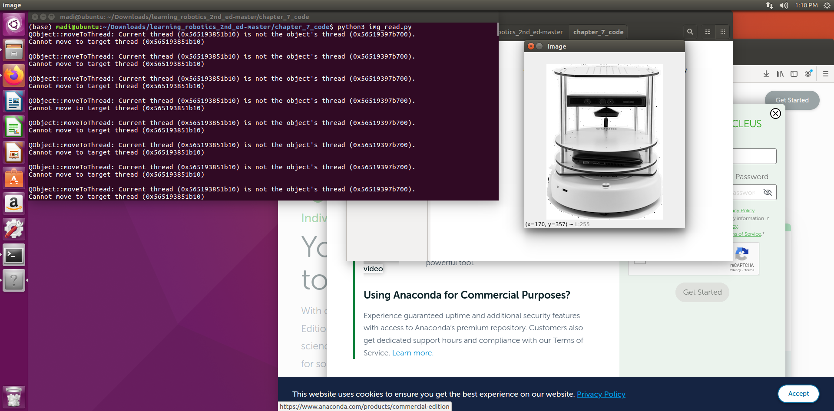

Designing a GUI for a Robot Using Qt and Python

* Step1: Installing PyQt in Ubuntu 16.04 LTS…

$ sudo apt-get install python-qt4 pyqt4-dev-tools

* Step2: Installing PySide on Ubuntu 16.04 LTS…

$ sudo apt-get install python-pyside pyside-tools

* Step3: Working with PyQt and PySide…

Start Qt Designer by entering the designer-qt4 command on the Terminal.

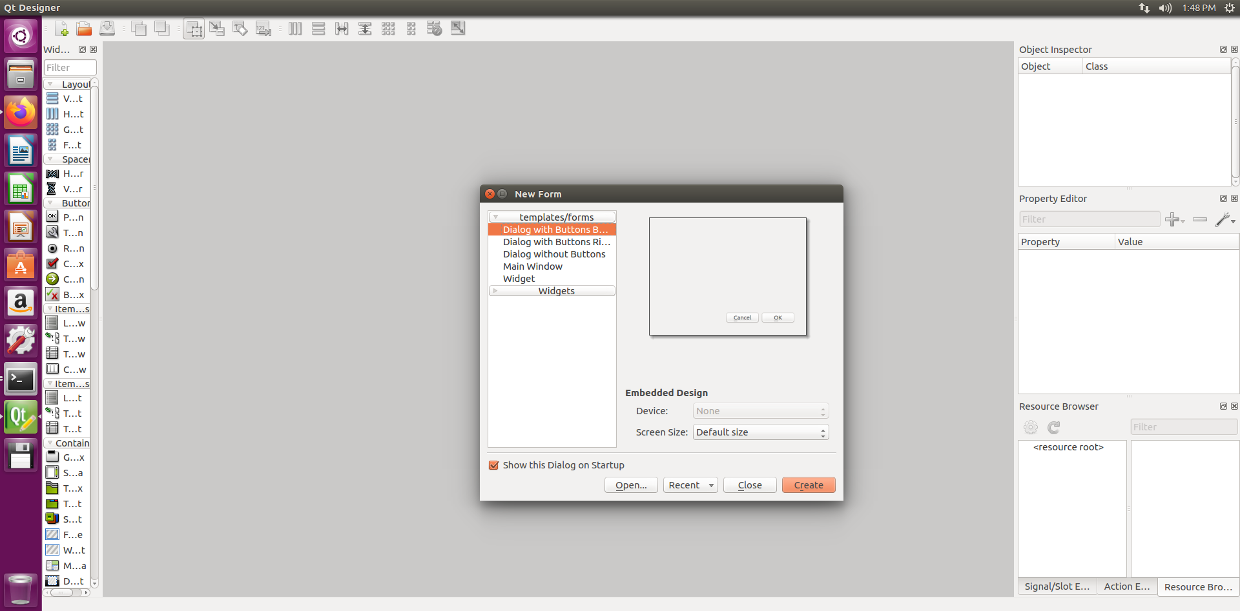

* Step4: Select the Widget option from the New Form

Window and click on the Create button…

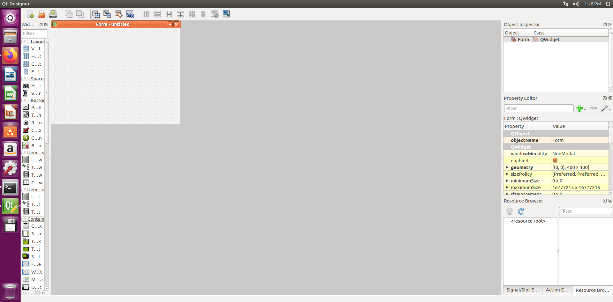

* Step5: dragge PushButton from the left-hand side window of Qt Designer..

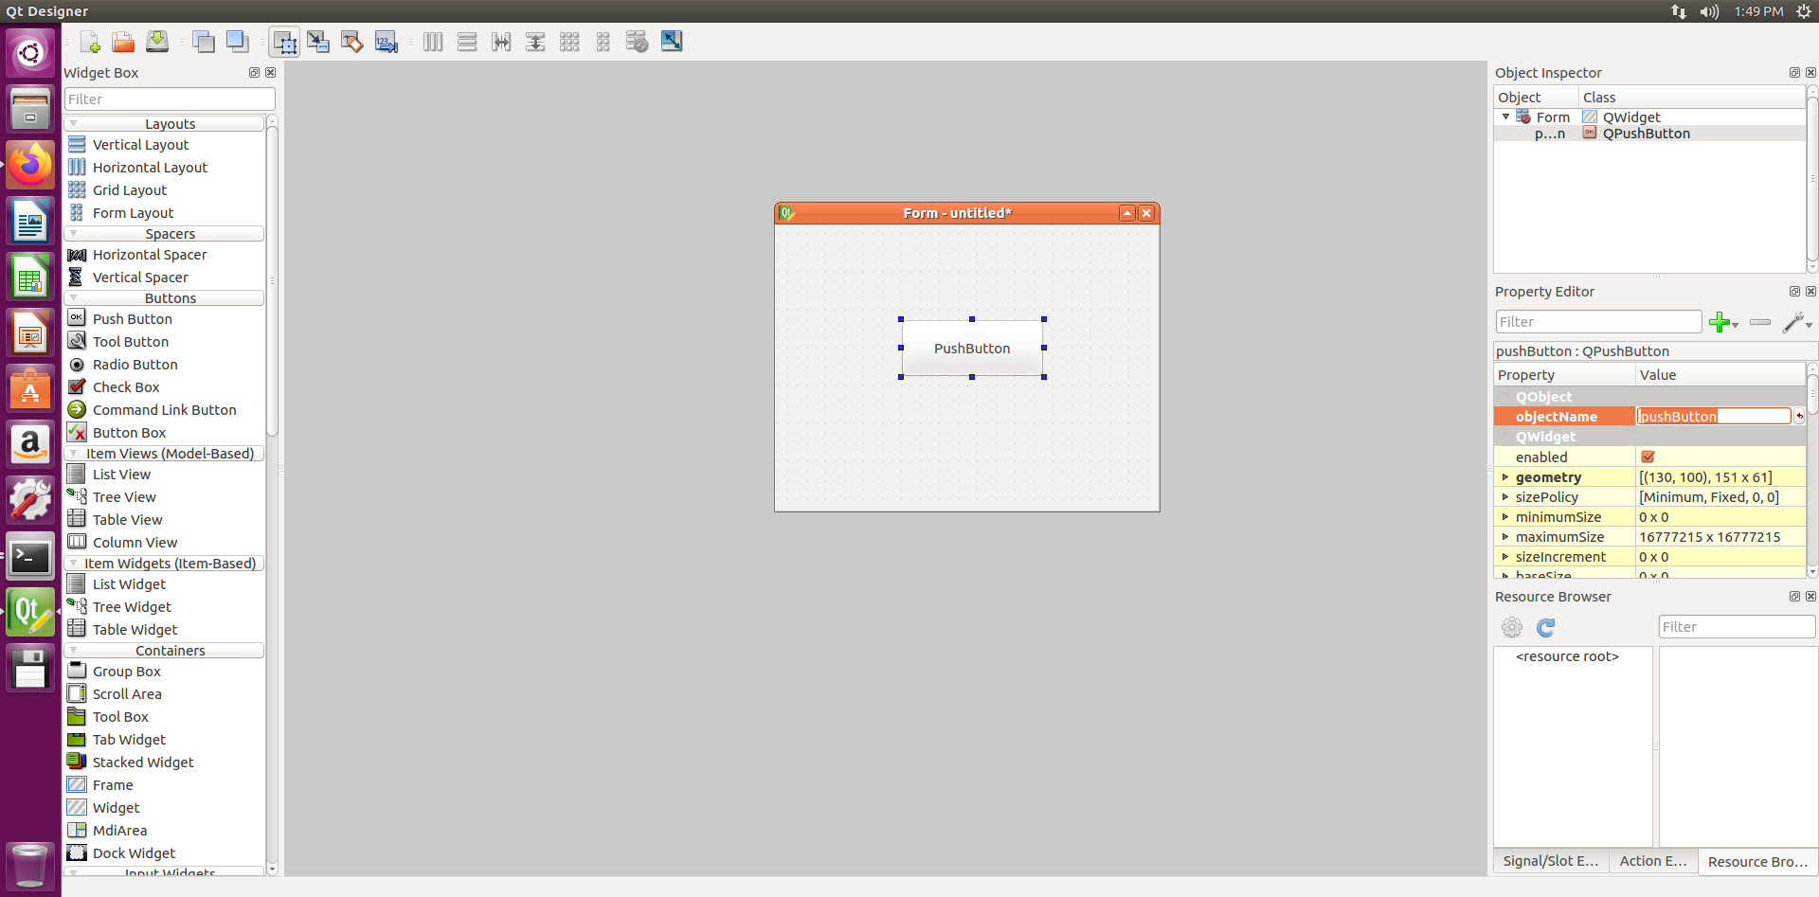

* Step6:select from top Edit signals/slots  then drag a line from the button and place the ground symbol in the main window.

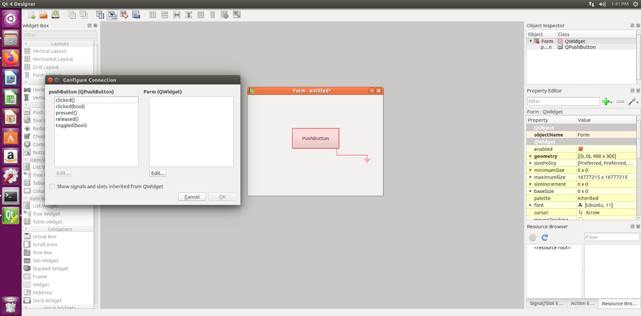

* Step7: Select the clicked() signal from the left-hand side and click on the Edit... button to create a new custom slot.

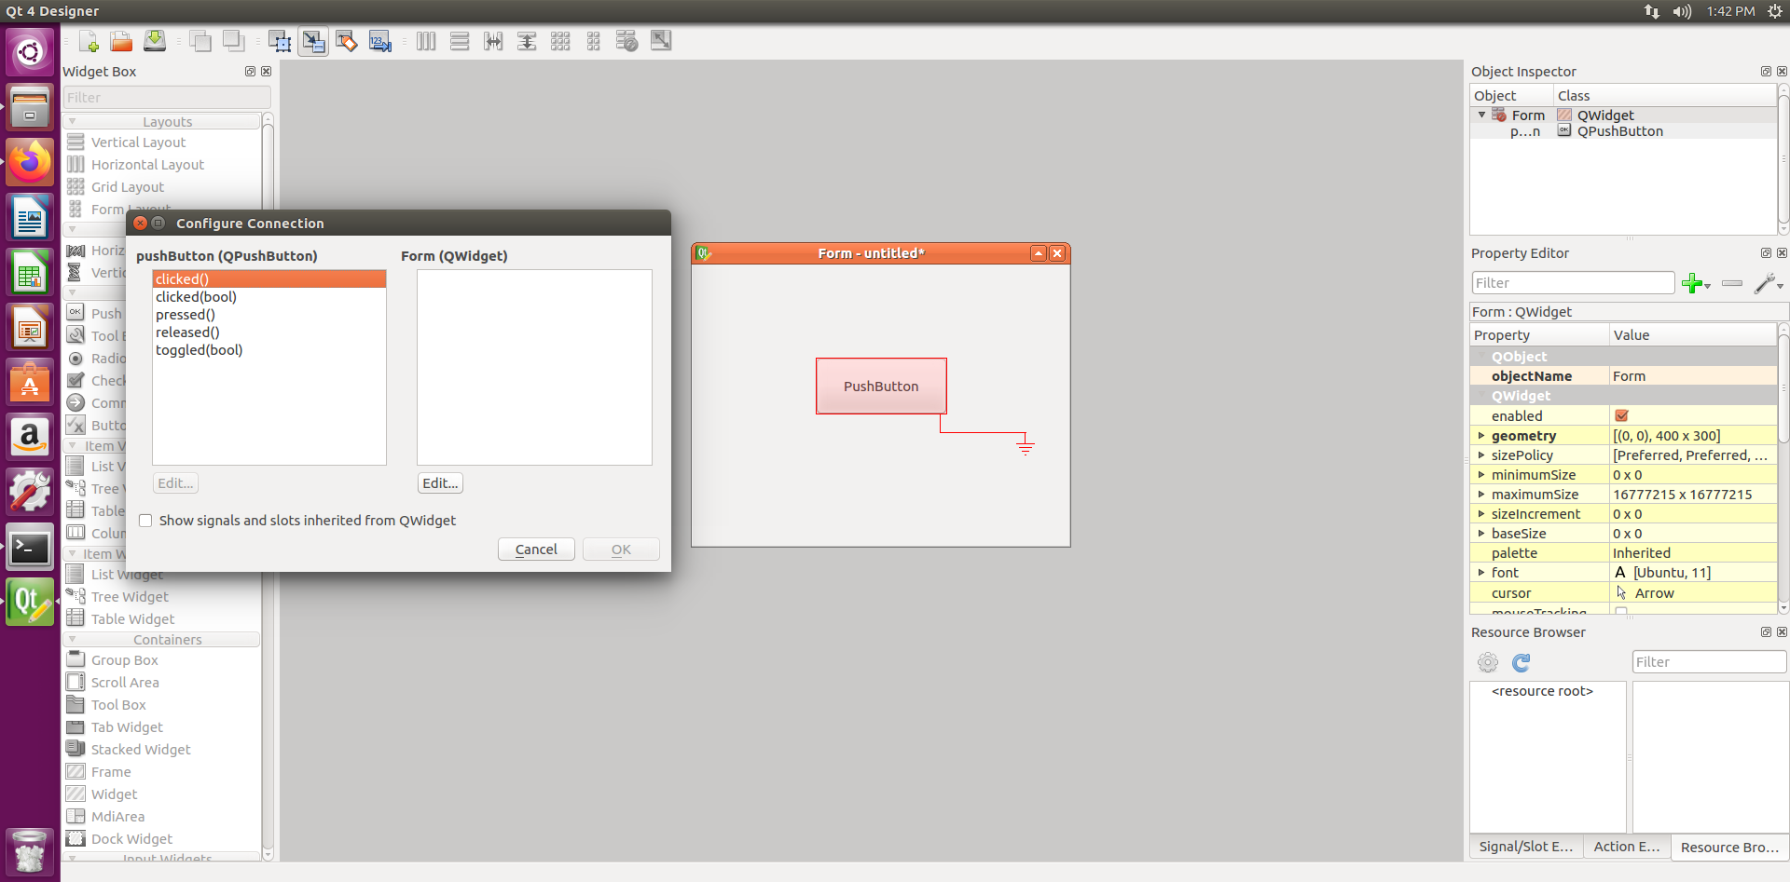

* Step8: create a custom function by clicking on the + symbol. then create a custom slot called message().

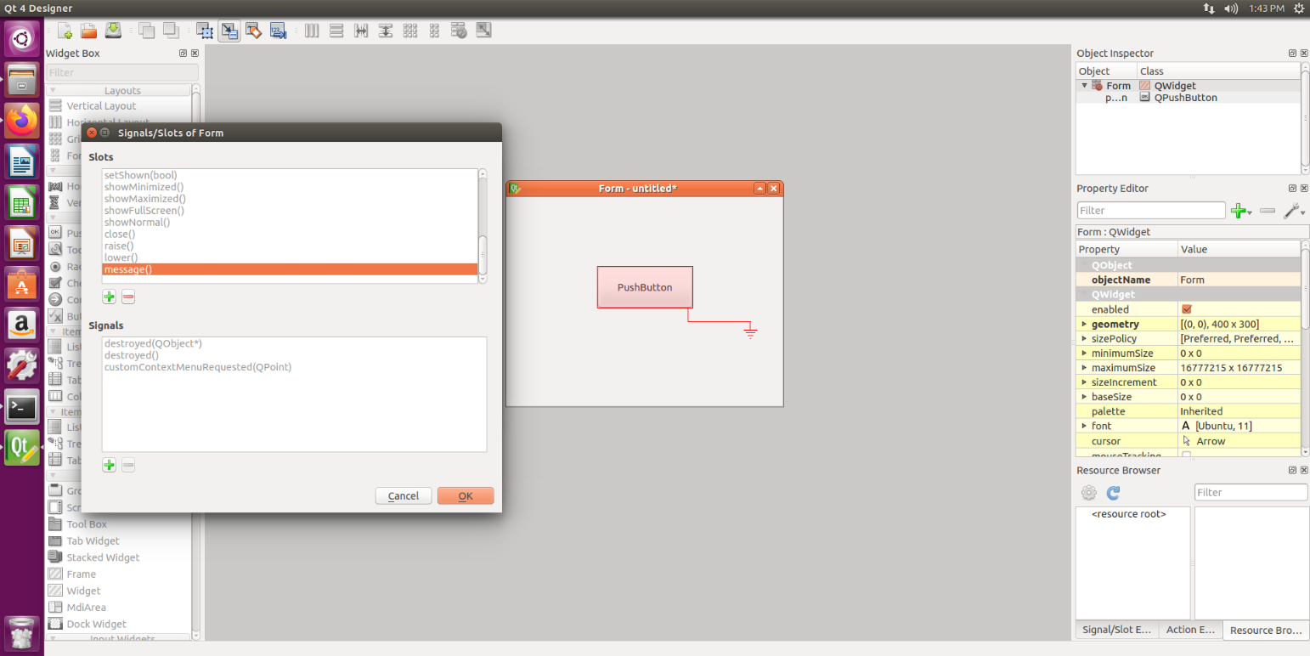

* Step9: Click on the OK button, save the UI file as hello_world.ui, and quit Qt Designer..

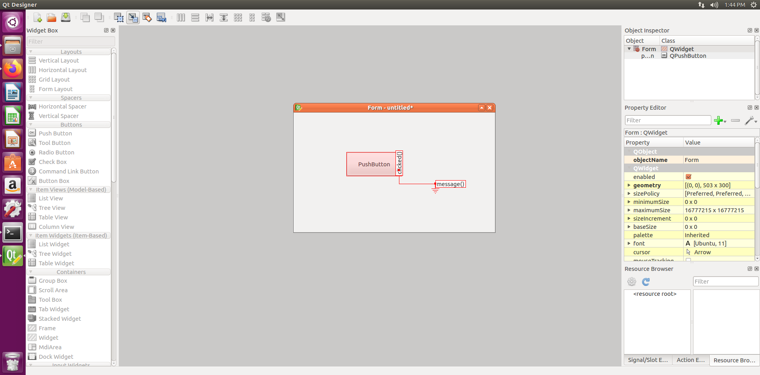

* Step10: The following command is to convert the UI into its PyQt equivalent file:

$ pyuic4 -x hello_world.ui -o hello_world.py

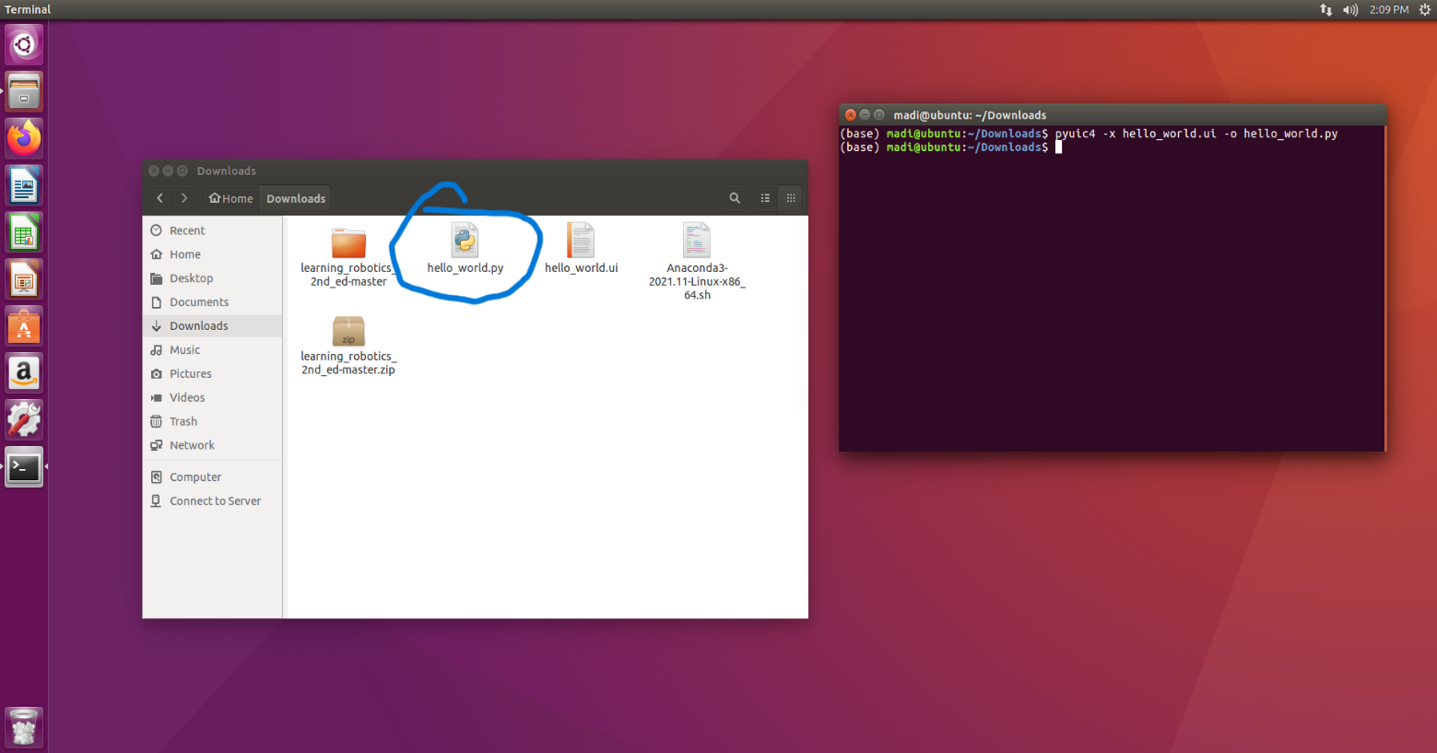

* Step11: replace the Form.message parameter with the self.message parameter

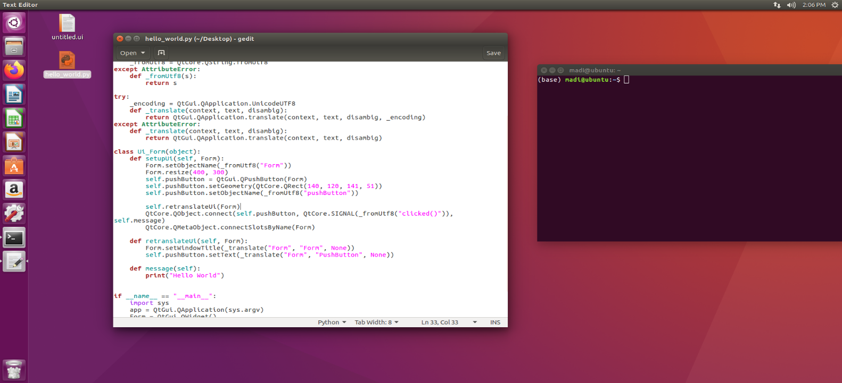

* Step12: we can execute the code and the output will look like this..

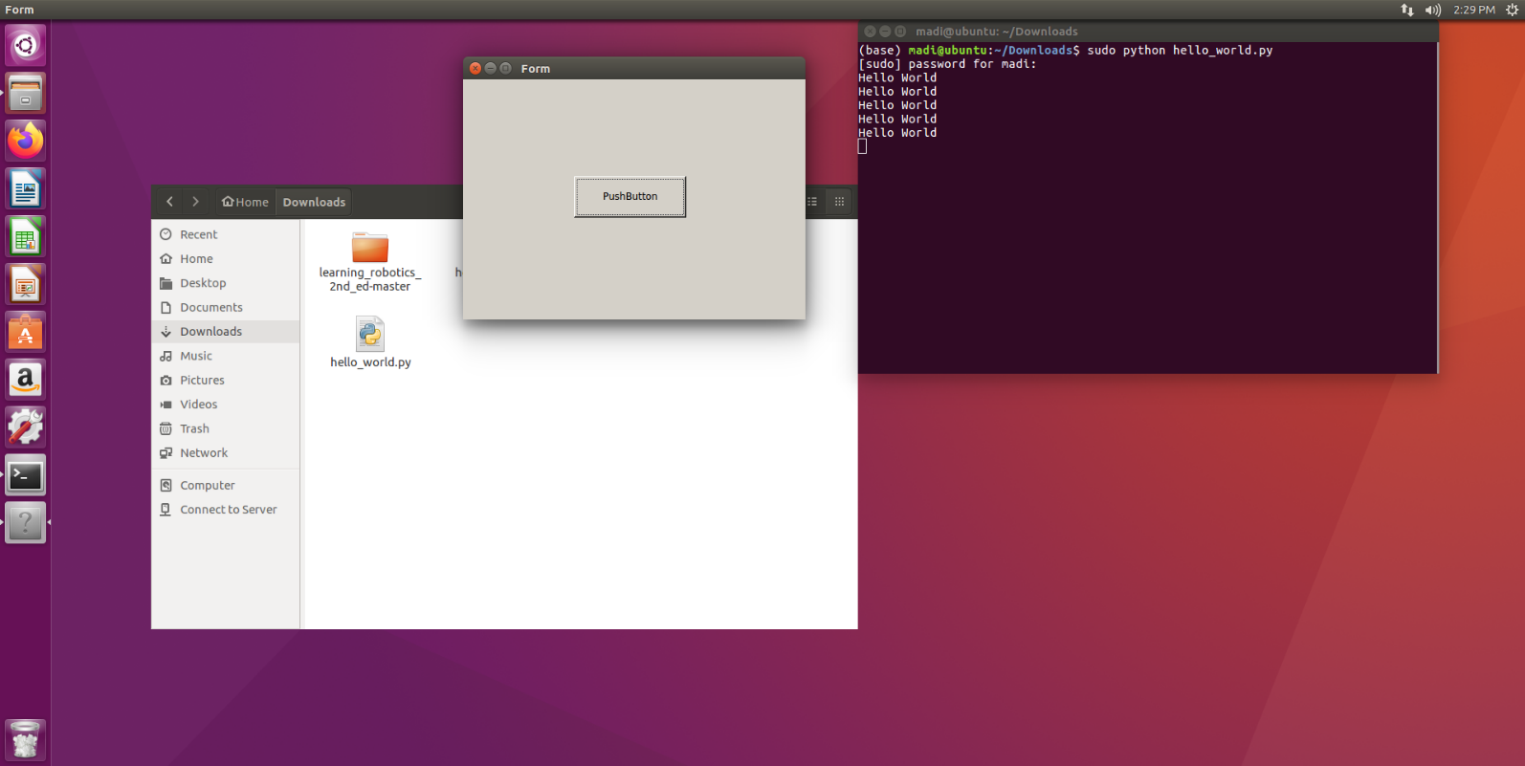

* reference: Learning Robotics using Python Design, simulate, program, and prototype an autonomous mobile robot using ROS, OpenCV, PCL, and Python by Lentin Joseph (z-lib.org) book.
* Name: Ramah Hashem Madi.